**Steps to complete the task:**

* After successfully configuration of postgresql and Python with their other dependencies.
* Now start the task and had paste result screenshot.
* Firstly creating a database that is mydb and after successfully creating database the create two sqlAlchemy model i.e Books and Author and inserting some raw-data on both tables.

As per the task each book can have many authors. So as in below screenshot Paul author writes serveral books like C Language, Python and ADA.

* authorid column is used as primary key in Author table.
* bookid and authorid column is used as composite primary key and authorid as foreign key in Books table.

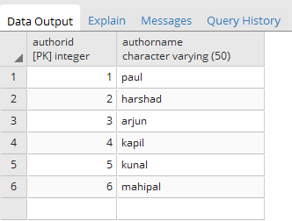

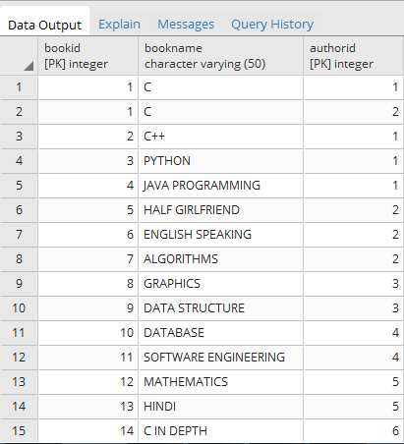

* By using python sqlalchemy, we can insert raw-data in a table (file name: insert_books.py, insert_author.py)
* Now main task that is to create a function to get the all books for a specified author (which is passed as an argument). And I make a python file name “function_module.py” where I write a query to select all the books of a particular author.
* Execute the query with “authorname = harshad” and the output is below:

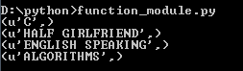

And “authorname = paul” and the output is below:

